The Great Pizza Analytics Challenge
Phase 1: Foundation & Inspection
Creating Table by running create query and inserting data running insert statement.
1. List all unique pizza categories (`DISTINCT`).
select distinct category FROM idc_pizza.pizza_types;
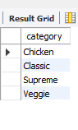
2. Display `pizza_type_id`, `name`, and ingredients, replacing NULL ingredients with `"Missing Data"`. Show first 5 rows.
SELECT pizza_type_id, name, coalesce(ingredients, 'Missing Data') as ingredients FROM idc_pizza.pizza_types limit 5;

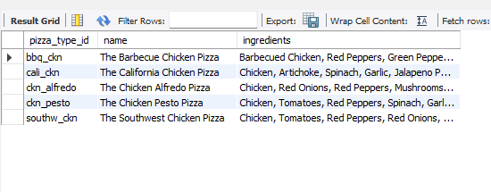.
3. Check for pizzas missing a price (`IS NULL`).
SELECT * FROM idc_pizza.pizzas where price is null;
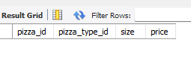
Phase 2: Filtering & Exploration
1. Orders placed on `'2015-01-01'` (`SELECT` + `WHERE`).
select * FROM idc_pizza.orders
where date = '2015-01-01';
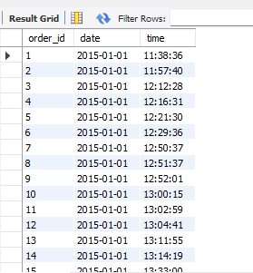

2. List pizzas with `price` descending.
select * FROM idc_pizza.pizzas
order by price desc;

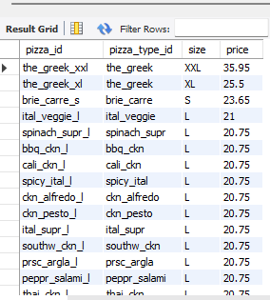

3. Pizzas sold in sizes `'L'` or `'XL'`.
SELECT * FROM idc_pizza.pizzas
where size in ('L','XL');

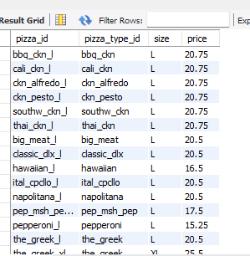

4. Pizzas priced between $15.00 and $17.00.
SELECT * FROM idc_pizza.pizzas
where price between 15.00 and 17.00;

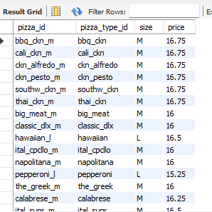

5. Pizzas with `"Chicken"` in the name.
SELECT * FROM idc_pizza.pizza_types
where name like '%chicken%';

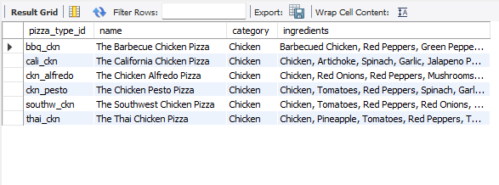

6. Orders on `'2015-02-15'` or placed after 8 PM.
SELECT * FROM idc_pizza.orders
where date ='2015-02-15' or time >='20:00:00'
;

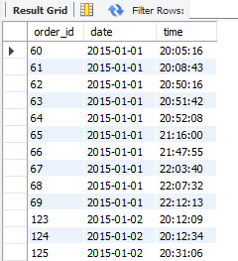

Phase 3: Sales Performance

1. Total quantity of pizzas sold (`SUM`).
SELECT sum(quantity)
as total_quantity_sold
FROM order_details;

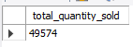

2. Average pizza price (`AVG`).
SELECT round(avg(price),2) as Avg_price
FROM idc_pizza.pizzas;

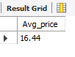

3. Total order value per order (`JOIN`, `SUM`, `GROUP BY`).

SELECT
o.order_id,
ROUND(
SUM(COALESCE(od.quantity, 0) * COALESCE(p.price, 0)), 2
) AS total_order_value
FROM orders o
JOIN order_details od
ON o.order_id = od.order_id
JOIN pizzas p
ON od.pizza_id = p.pizza_id
GROUP BY o.order_id;

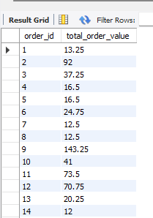

4. Total quantity sold per pizza category (`JOIN`, `GROUP BY`).
SELECT
pt.category,
sum(coalesce(od.quantity, 0)) as toatal_quantity_sold
FROM order_details od
join pizzas p
on od.pizza_id = p.pizza_id
JOIN pizza_types pt
ON p.pizza_type_id= pt.pizza_type_id
GROUP BY pt.category;

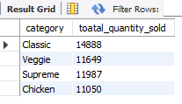

5. Categories with more than 5,000 pizzas sold (`HAVING`).
SELECT
pt.category,
sum(coalesce(od.quantity, 0)) as toatal_quantity_sold
FROM order_details od
join pizzas p
on od.pizza_id = p.pizza_id
JOIN pizza_types pt
ON p.pizza_type_id= pt.pizza_type_id
GROUP BY pt.category
having sum(coalesce(od.quantity, 0)) > 5000;

6. Pizzas never ordered (`LEFT/RIGHT JOIN`).

SELECT
p.pizza_id,
pt.name AS pizza_name,
p.size
FROM pizzas p
JOIN pizza_types pt
ON p.pizza_type_id = pt.pizza_type_id
LEFT JOIN order_details od
ON p.pizza_id = od.pizza_id
WHERE od.order_id IS NULL;

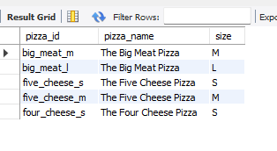
7. Price differences between different sizes of the same pizza (`SELF JOIN`).

SELECT
pt.name AS pizza_name,
p1.pizza_type_id,
p1.size AS size_1,
p2.size AS size_2,
ROUND(p2.price - p1.price, 2) AS price_difference
FROM pizzas p1
JOIN pizzas p2
ON p1.pizza_type_id = p2.pizza_type_id
AND (CASE p1.size
WHEN 'S' THEN 1
WHEN 'M' THEN 2
WHEN 'L' THEN 3
WHEN 'XL' THEN 4
WHEN 'XXL' THEN 5
END)
<
(CASE p2.size
WHEN 'S' THEN 1
WHEN 'M' THEN 2
WHEN 'L' THEN 3
WHEN 'XL' THEN 4
WHEN 'XXL' THEN 5
END)
JOIN pizza_types pt
ON p1.pizza_type_id = pt.pizza_type_id
ORDER BY
pt.name,
CASE p1.size
WHEN 'S' THEN 1
WHEN 'M' THEN 2
WHEN 'L' THEN 3
WHEN 'XL' THEN 4
WHEN 'XXL' THEN 5
END;

SELECT
pt.name AS pizza_name,
p1.pizza_type_id,
p1.size AS size_1,
p2.size AS size_2,
ROUND(p2.price - p1.price, 2) AS price_difference
FROM pizzas p1
JOIN pizzas p2
ON p1.pizza_type_id = p2.pizza_type_id
AND FIELD(p1.size, 'S','M','L','XL','XXL')
< FIELD(p2.size, 'S','M','L','XL','XXL')
JOIN pizza_types pt
ON p1.pizza_type_id = pt.pizza_type_id
ORDER BY
pt.name,
FIELD(p1.size, 'S','M','L','XL','XXL');

